AWS VPC Configuration
Step 1: Create a VPC
Go to the AWS Management Console → VPC service.
Click “Create VPC”.
Select “VPC only”.
Name tag: myvpc01
IPv4 CIDR block: 10.0.0.0/16
Tenancy: Default
Click Create VPC.
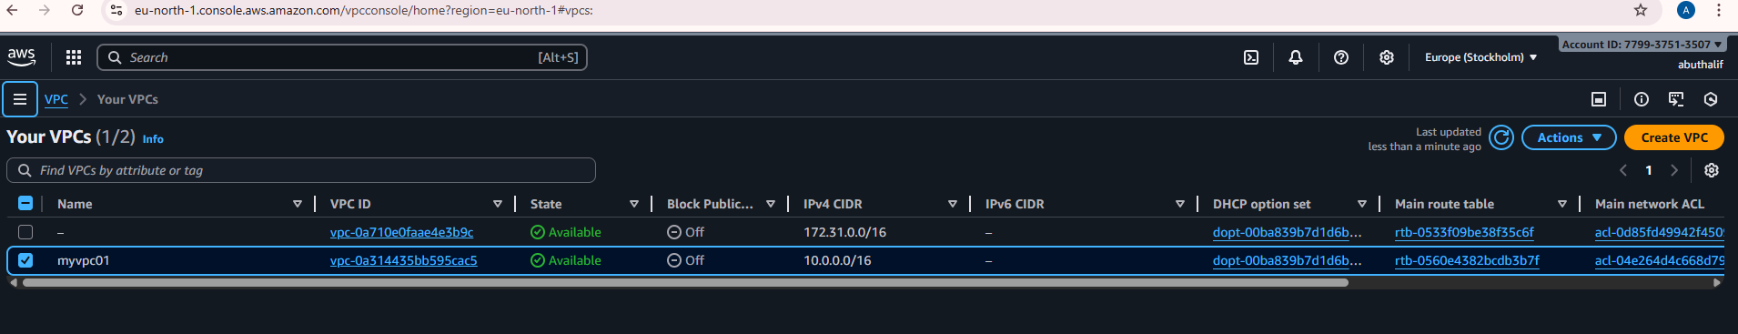
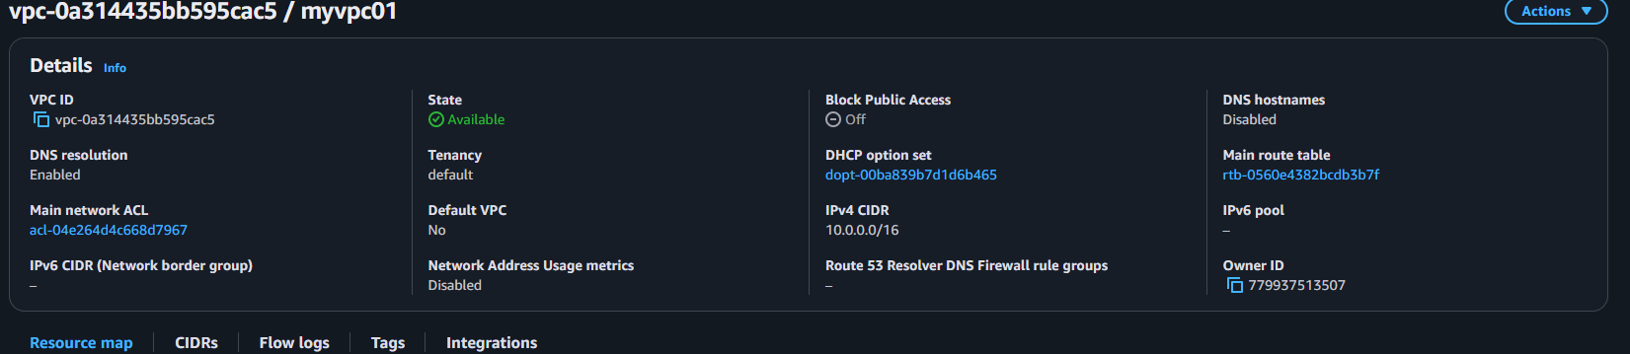

Create an Internet Gateway (IGW)
In the VPC dashboard, go to Internet Gateways → Create Internet Gateway.
Enter:
Name tag: MyInternetGateway
Click Create Internet Gateway.
Select it click Actions Attach to VPC choose MyVPC.
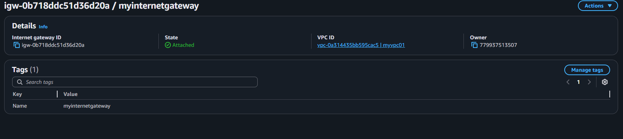
IGW attached to your VPC.
Create Subnets
Go to Subnets Create Subnet.
VPC ID: myvpc01
• Subnet name: PublicSubnet
• IPv4 CIDR block: 10.0.1.0/24
Click Create Subnet.
(b) Private Subnet
Click Create Subnet again.
• VPC ID: myvpc01
• Subnet name: PrivateSubnet
• Availability Zone: (same or different AZ)
• IPv4 CIDR block: 10.0.2.0/24
Click Create Subnet.
• Public: 10.0.1.0/24
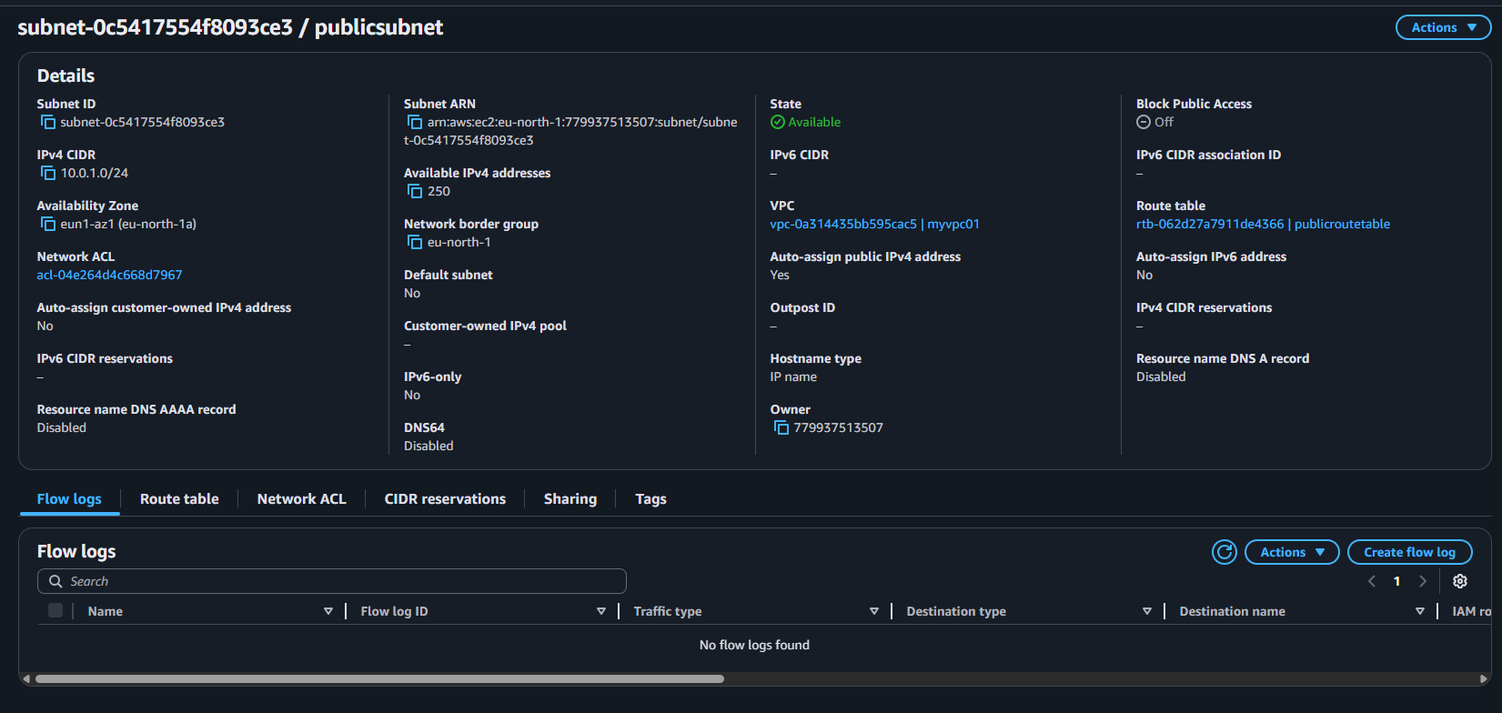
• Private: 10.0.2.0/24
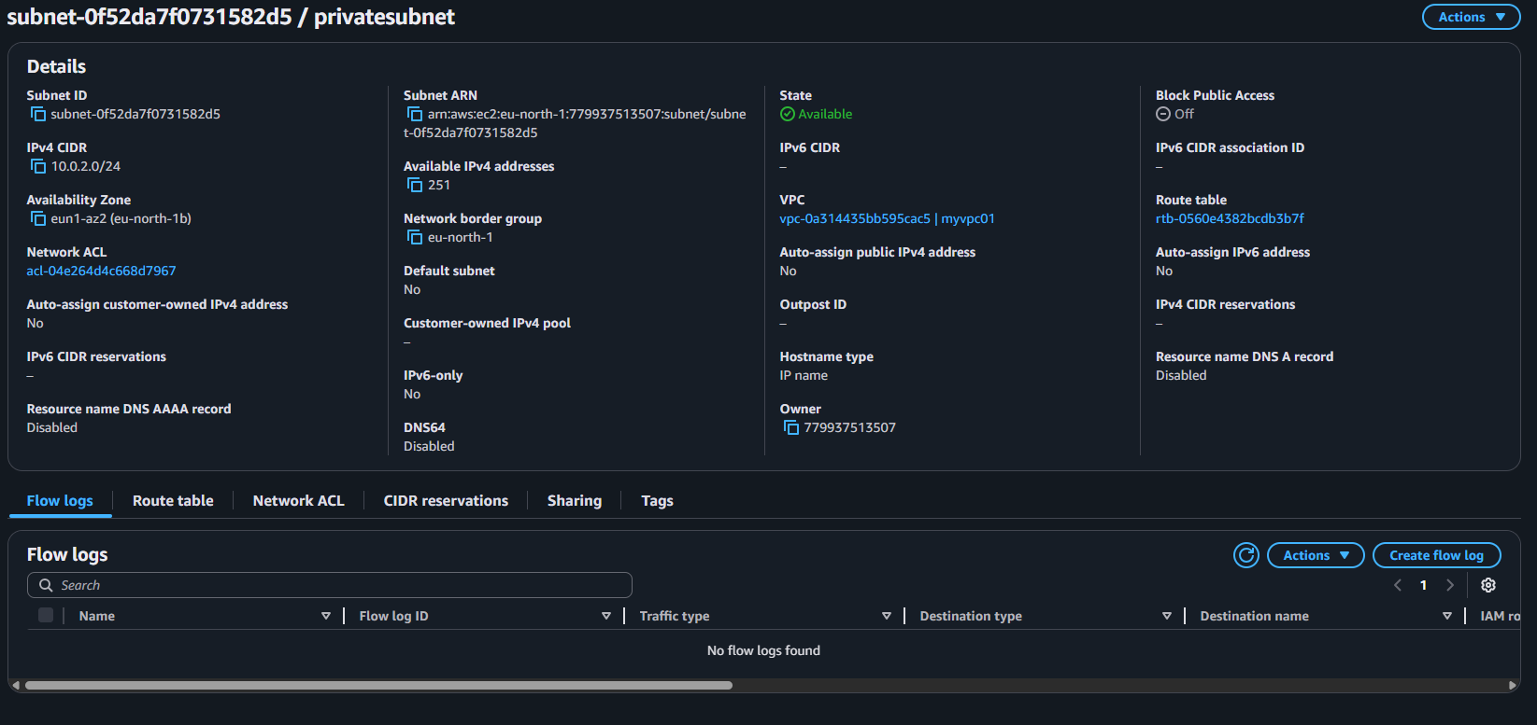
Create Route Tables
Public Route Table
• Go to Route Tables → Create route table.
• Name: PublicRouteTable
• VPC: myvpc01
• Click Create Route Table.
• Select it Routes tab Edit routes Add route:
Destination: 0.0.0.0/0
Target: Internet Gateway MyInternetGateway
• Click Save changes.
- • Go to Subnet associations - Edit subnet associations - select PublicSubnet and Save.
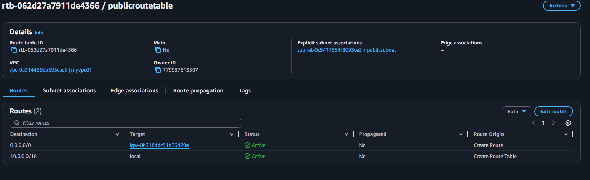
Configure Public Subnet for Auto-Assign Public IPs
Go to Subnets → PublicSubnet → Edit subnet settings.
Enable “Auto-assign IPv4 public address.”
Save.

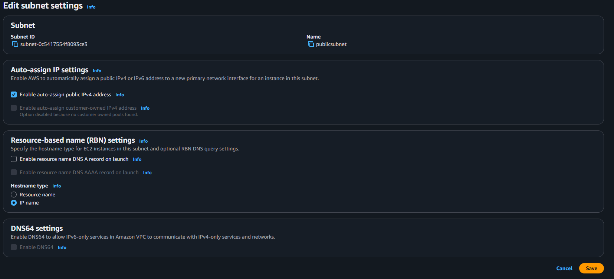
Create a Security Group
• Go to Security Groups Create Security Group.
• Name: publicsg
• Description: Allow SSH and HTTP
• VPC: MyVPC
• Add inbound rules:
SSH: TCP, port 22, source = your IP (My IP)
HTTP: TCP, port 80, source = Anywhere (0.0.0.0/0)
Save.
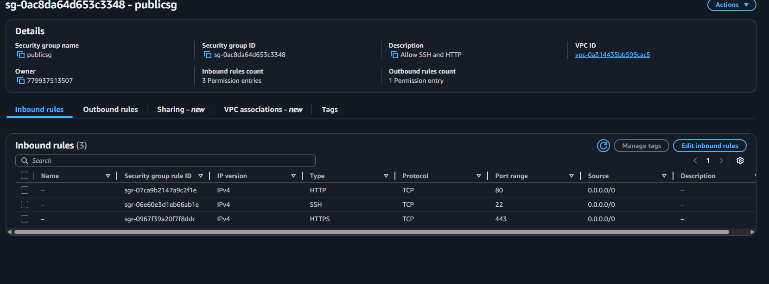
Launch a Linux EC2 Instance
Go to EC2 Instances Launch Instance.
Name: MyLinuxServer
AMI: Ubuntu
Instance type: t3.micro
Under Network settings:
VPC: MyVPC
Subnet: PublicSubnet
Auto-assign public IP: Enable
Security Group: Select (publicsg)
Choose an existing key pair or create a new one for SSH access.
Click Launch Instance.
Your Linux EC2 instance is now running in the public subnet with Internet access.
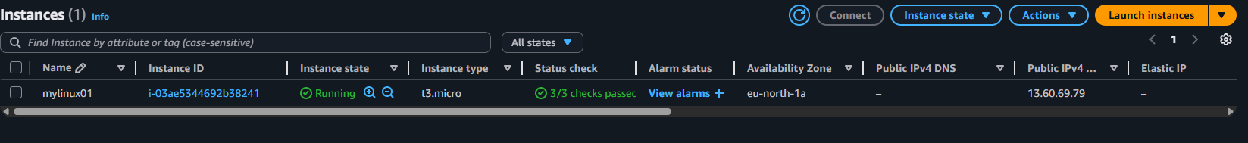
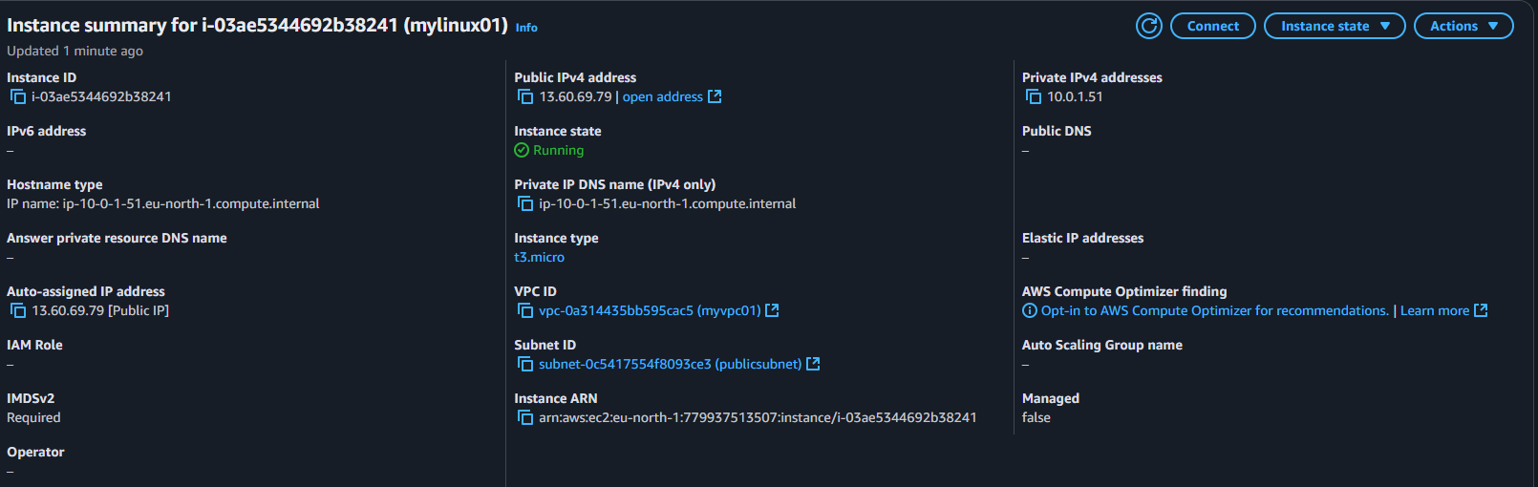
AMI IMAGE
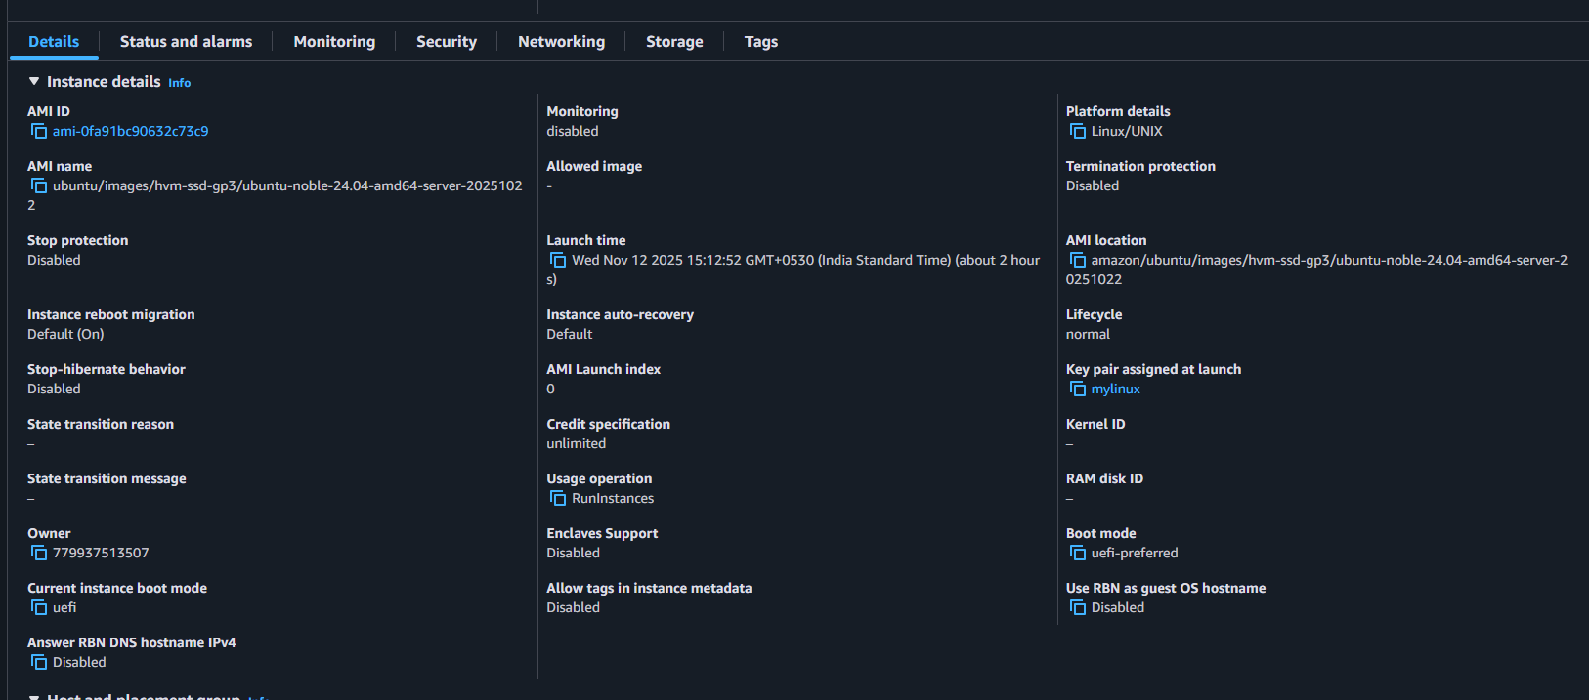
Security Group
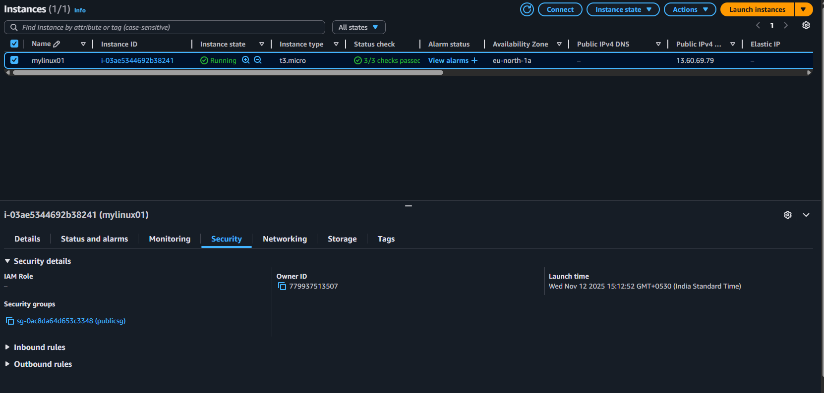
Networking setup
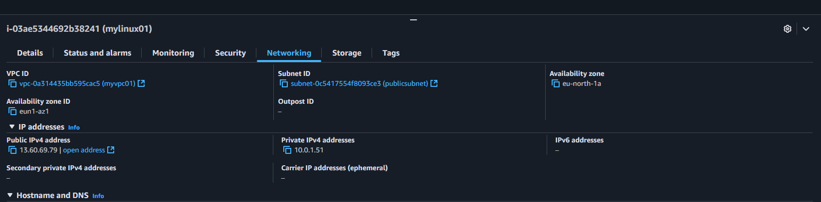

Putty login
Finally login to putty
